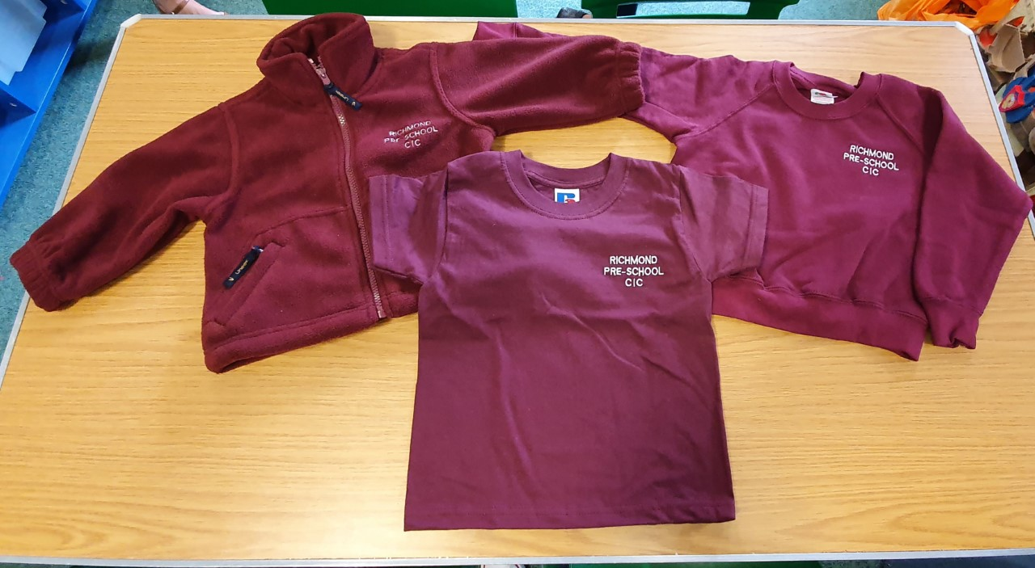
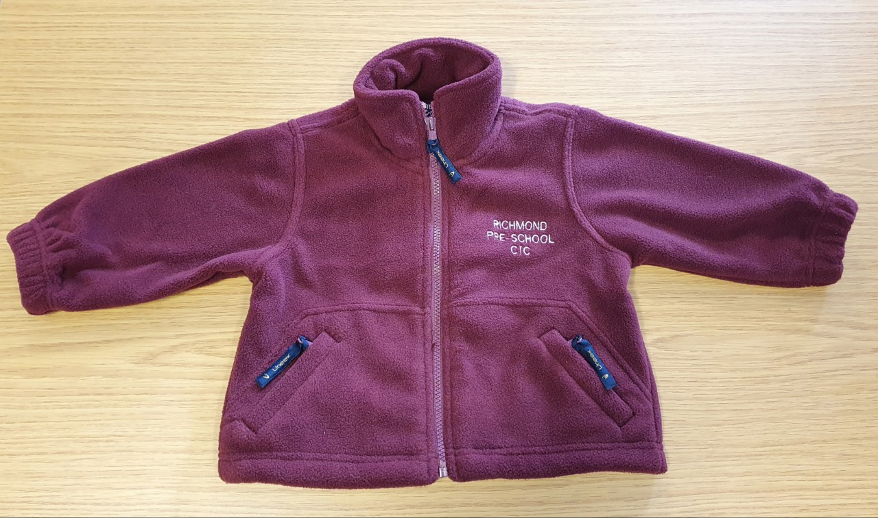
£15.25
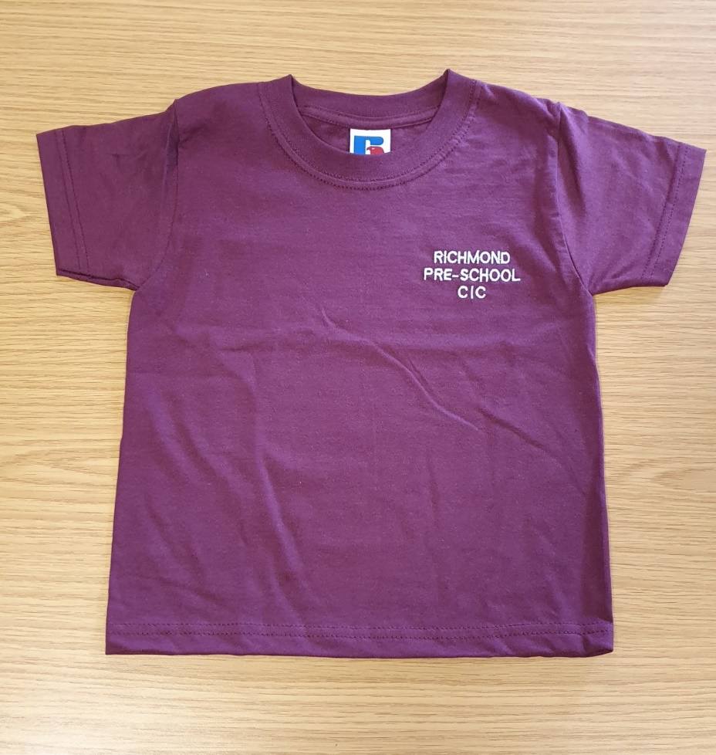
£6.25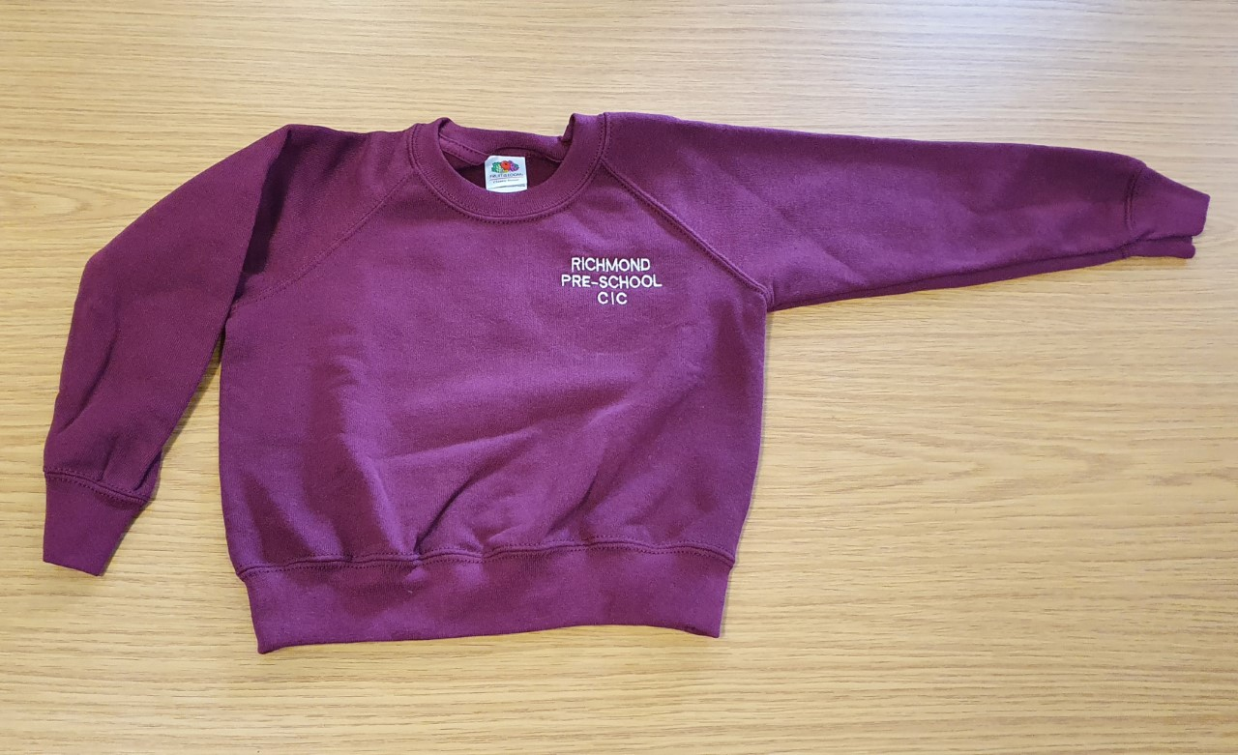
£10.25

Children’s Uniform Order for Richmond Pre-school
Child’s Name: …………………………………………………………………………………
Please write the number you would like to order of each size.
T-shirts |  | Sweatshirts |  | Zipped fleece
Size | Qty | Size | Qty | Size | Qty
Age 1-2 |  |  |  | Age 2
Age 3-4 |  | Age 3-4 |  | Age 3-4
Age 5-6 |  | Age 5-6 |  | Age 5-6
Total at £6.25 each |  | Total at £10.25 each |  | Total at £15.25 each

Total to pay …………………………… ( payment with order please)
Date Order Collected : ………………

